
RIGHTS OF CHILDREN AND YOUNG PERSONS RECEIVING SERVICES

Every child and young person accessing services from Children’s Respite has the following rights:

Your Rights


To be heard and express your views freely about matters that affect you.
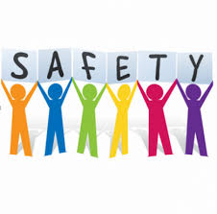

Safety and to be protected from any type of abuse.
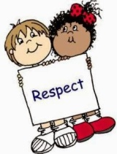

Respect and respectful interactions.

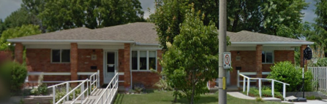
A clean and safe place to stay.

Nutritious food



Honesty - Employees will speak with you when you do something wrong and help you to understand and learn from your mistakes.

Decision Making about the services provided to you. We hope you like the services offered to you, and you do have the right to say “no”.



Express your feelings and concerns and recommend changes about the services provided to you. You have the right to make a complaint, have your complaint reviewed and be told about the review results in a manner that you understand. You will be told updates about the complaint, every two (2) weeks while it is reviewed, and CLC-K will keep written records of the complaint and review.

Your right to private time.




Beliefs - You have the right to practice the religion, creed or spiritual beliefs of your choosing.

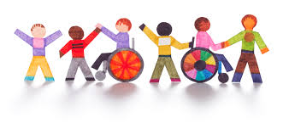
Inclusion in your community. To participate with recreational activities in a community setting whenever possible.

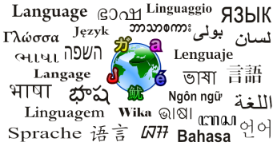
All in language suitable to your understanding.

You have the right to receive supports and services that respect your:

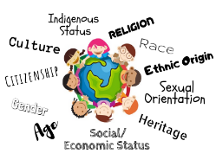

These are your rights, your choices, your voice to be heard,
speak up!



Office of the Ombudsman of Ontario
to investigate concerns about children and youth (younger than 18 years old) __________________________________

You have the right to know that there is a group of people at the Children & Youth Unit of the Ombudsman’s Office that can help you if you have an unresolved concern.

Toll Free: 1 (800) 263-2841 - Direct
General: 1 (800) 263-1830
TTY: 1 (866) 411-4211

Email: cy-ej@ombudsman.on.ca

Address: Bell Trinity Square

