CLC-K Presents the 3rd Annual
Jonathan Daniel Stone Fund Awards


Community Living Chatham-Kent is pleased to announce the recipients of the Jonathan Daniel Stone Fund. Each recipient received a $1000.00 award to assist with the achievement of their initiative. The awards were presented on Thursday, December 22, 2016.

Kamani Phillip is 7 years old and attends McNaughton Avenue Public School. He loves his dog and is an extremely affectionate to those closest to him. As Kamani loves animals, music and the water, the fund will provide him the opportunity to participate in activities including Fun with Music, the Acceptional Riders program, swimming lessons, and bowling.

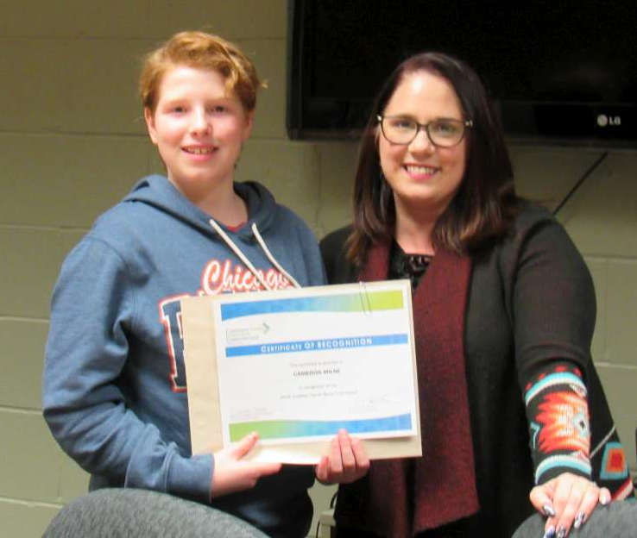
The second grant is awarded to Cameron Milne, a grade 6 student attending McNaughton Avenue Public School. Cameron is a kind young man and enjoys making new friends. The fund will provide social activity opportunities including, the Acceptional Riders program, swimming lessons, bowling and creative creations at Crockerdoodle. Cameron and his family are new to the Chatham-Kent community and will be able to expand their social networks.
This fund initiated by Jonathan Daniel Stone’s family, celebrates his life. Daniel was a child who had autism and died suddenly at the age of 11 in May of 2013. The purpose of the fund is to annually support initiatives to assist children and their families who have been diagnosed with autism and/or other intellectual disabilities. Daniel's fund can be utilized for but is not limited to: recreational activities, educational workshops for parents and siblings, advocacy, vocation and life skills development, assistive devices and equipment that promote and facilitate learning or communication. The recipients were selected by a review committee comprised of Dr. Jonathan and Sarah Stone, a person supported by Community Living Chatham-Kent, two Community Living Chatham-Kent Managers and a Community Living Chatham-Kent Board Member.

